Tab 1

**TRC3500 Use of AI Disclosure Form**

In TRC3500, you may use any AI tools at your disposal, in any capacity, to complete the assigned work. However, you must disclose which tools you used and how. Generative AI produces feedback or content that may be incorrect or inappropriate. You are fully responsible for the state of work that you submit.

**Instructions**

* An AI disclosure form must be submitted for the group with every report. Appendix and example need not be included.
* Address every task category listed in the form
* Add tasks if you feel you did something that doesn’t fit in any category but warrants disclosure
* All uses (“Y”) must indicate what tool you used and for what purpose
* See explanations of the categories in the appendix

| Task | N | Y | If Y, specify tool and scope |
| --- | --- | --- | --- |
| Coding: algorithms | X |  |  |
| Coding: syntax assistance | X |  |  |
| Coding: debugging | X |  |  |
| Coding: refactoring | X |  |  |
| Coding: documentation | X |  |  |
| Writing | X |  |  |
| Reviewing text | X |  |  |
| Brainstorming | X |  |  |
| Image generation | X |  |  |



Table of Contents

1.0 Introduction 4

2.0 Electrical Circuit 4

3.0 Methodology 5

4.0 Transfer Function Comparision and Justification 5

5.0 Sensor Characteristics 7

6.0 Conclusion 8

## 

## 1.0 Introduction

This report outlines the design, calibration, and performance evaluation of an accurate and reliable resistive soil moisture sensor built at a cost-effective rate. The sensor is integrated with the STM32 microcontroller to provide real-time moisture readings as serial ADC outputs. It is currently for indoor use, but its working principles can be built upon to create equipment suitable for use in agriculture and environmental monitoring.

## 2.0 Electrical Circuit

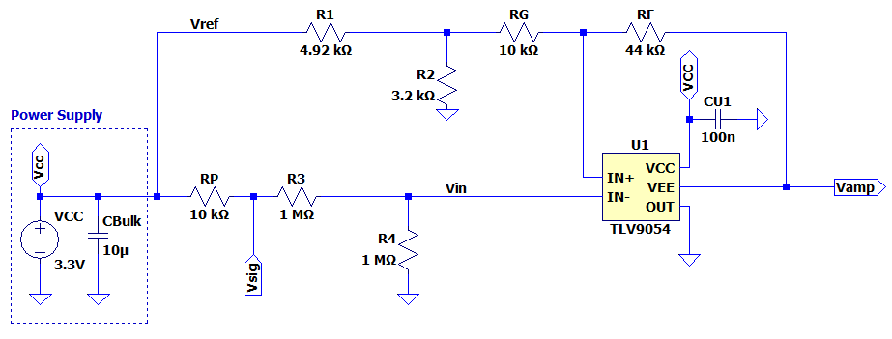

*Fig 1. Schematic diagram of calibration and signal conditioning circuit*

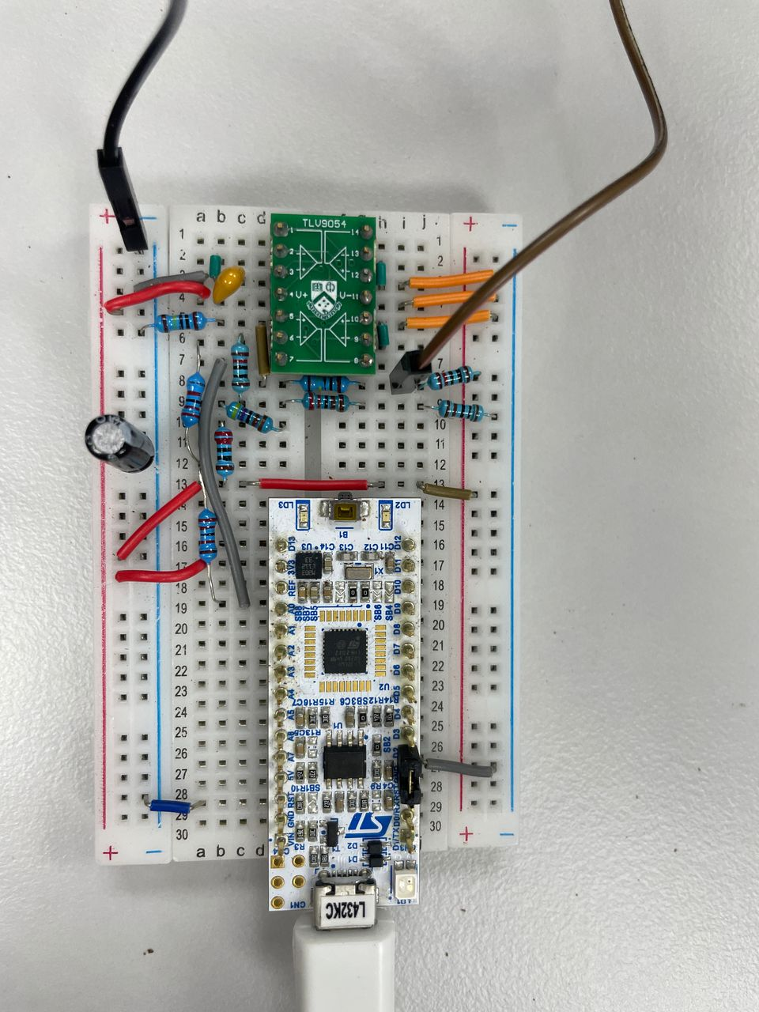 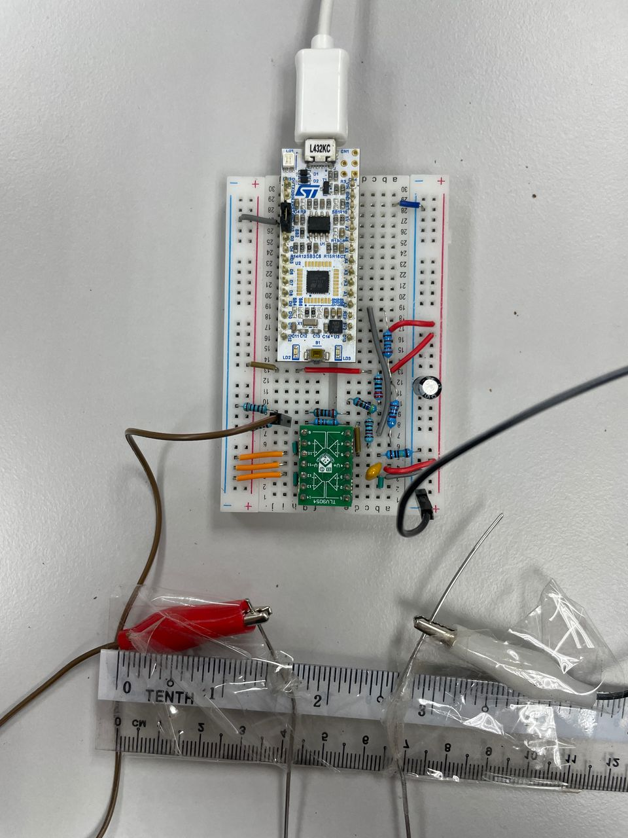

*Fig 2. Top view and close up view of the sensor and conditioning circuit,*

*including the probes*

The circuit utilises the STM32 microcontroller to send data to the laptop interface, while the TLV9054 op amp is used with corresponding resistors to create a conditioning circuit to maximise the detection resolution. Two stainless steel probes are attached to a non-conducting ruler to maintain a set distance apart when placed in the soil. The voltage between the two probes is then measured by the sensor and converted to the soil water level.

The resistor values for the conditioning circuit can be seen in the schematic. These resistors were taken from the E3 set. R1’s ideal resistance is achieved with 4.7kΩ and 220Ω in series, R2 with 2.2kΩ and 1kΩ in series, and RF with two 22kΩ in series. With these, we are able to perfectly replicate the theoretical values.

## 3.0 Methodology

First, a calibration circuit was built to take the voltage readings of the stainless steel probes at different amounts of water in the soil. The collected data was logged and a transfer function produced, which was then used to calculate the resistor values required for the sensor’s conditioning circuit. After inspecting the data and the transfer function, it was determined that the sensor only had a linear variation from the range of 0ml to 60ml. Thus, that was chosen as the full span of the sensor.

The voltage varied from 2.41V to 3.22V, which then needed to be mapped to the range of 0.5V to 3.0V for compatibility with the microcontroller. We then conducted another round of testing under the same conditions to relate the ADC values to the water level, which we mapped to a transfer function.

Careful considerations were implemented to ensure accurate and optimal data was collected. Two pucks of soil were always crushed finely in the testing cup prior to the addition of water to minimise clumping, and the water was always carefully measured with a pipette.

The soil was always stirred well for a period of about one minute and packed down before the probes were placed inside. Packing down is important as this affects the distance between water molecules in the soil and thus soil conductivity.

The probes were positioned hovering above the base of the cup to ensure they were fully surrounded by the soil, yet able to avoid any pools of water at the base. After placement, a reading would be logged after 20 seconds. That was determined as the sensor’s settling time, as the ADC values showed minimal fluctuation after that period of stabilisation.

After completing data collection across the full-span range, the transfer function was calculated using *polyfit* and *polyval* commands in Matlab. Then, several rounds of further testing were conducted to refine the transfer function.

## 4.0 Transfer Function Comparision and Justification

The derived ADC transfer function is a linear first-order function that illustrates an inversely proportional relationship between ADC value and water level. This matches the theoretical linear behavior, though the data is not perfectly linear as expected in a real-world scenario. The voltage-based transfer function is a linear first-order function as well, but the data shows more variation because it was taken at a different stage of the sensor’s signal processing. Both transfer functions are well within the 10% dotted deviation lines shown above and below the transfer function.

However, limitations like manufacturing tolerances of the base materials may still result in minor differences from the ideal transfer function. Environmental factors like humidity and room temperature may also cause differences, as well as even more minute details like the specific makeup of the soil puck and the water source that may minorly affect the soil conductivity.

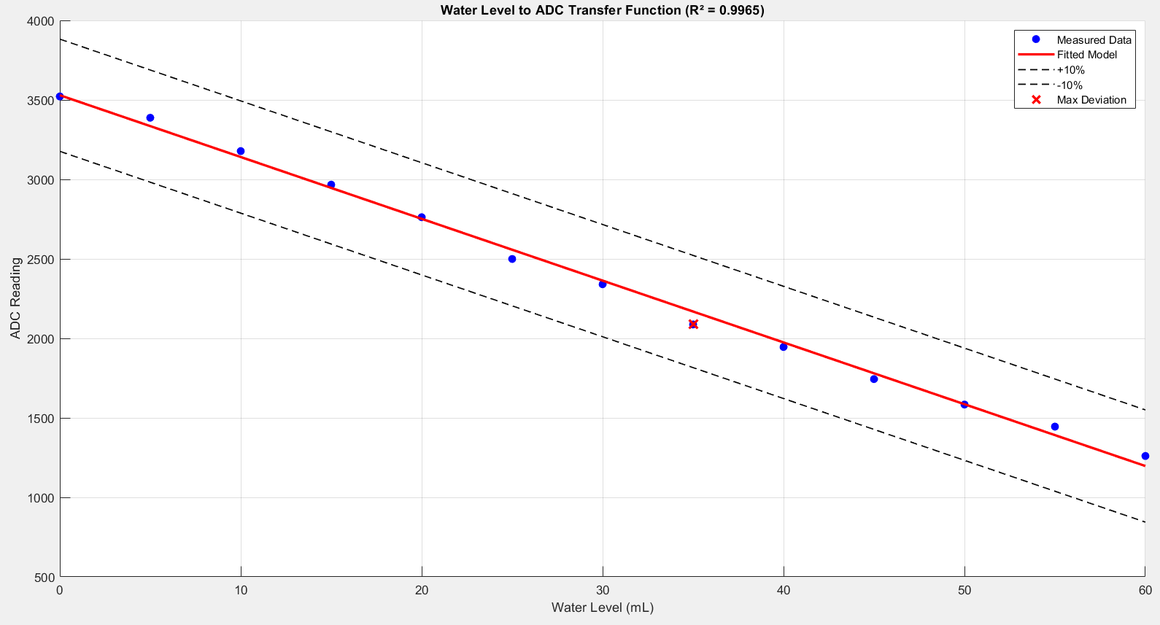

*Fig 3. Transfer function of the mean ADC reading against the water level*

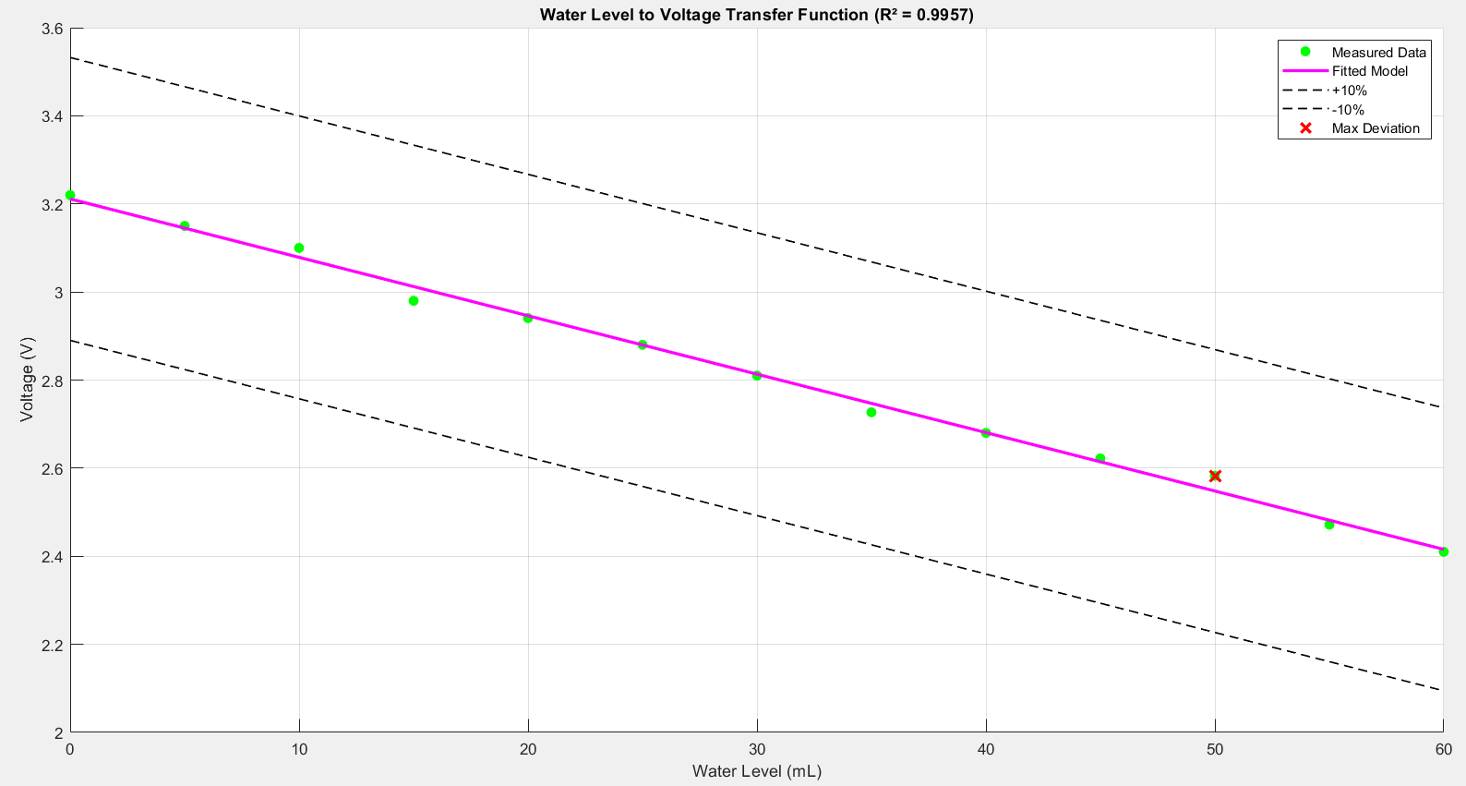

*Fig 4. Transfer function of the voltage reading against the water level*

The voltage-based transfer function is found prior to calibration, and a new circuit was built to scale the dynamic voltage range to the ADC output. Then, the transfer function is fitted to the ADC output, which is across a much larger range where small changes in voltage can be detected with larger ADC variations. The final transfer function utilised during the sensor’s usage is the ADC transfer function.

Both transfer functions are very accurate with an R2 value of over 0.99, proving minimal deviation from collected data. The functions are outlined below.

*Table 1: Transfer function of ADC and voltage graph*

|  | R² | Transfer function |
| --- | --- | --- |
| ADC Transfer Function | 0.9965 | ADC = -38.8718 * WaterLevel + 3529.5162 |
| Voltage Transfer Function | 0.9957 | Voltage = -0.0131 * WaterLevel + 3.2088 |

## 5.0 Sensor Characteristics

The sensor’s entire fabrication and testing was carried out in an air-conditioned lab environment, with ambient humidity estimated to be around 60%. The sensor may work differently outdoors, where humidity is significantly higher. However, it is primarily meant to be used indoors and thus is designed and measured as such.

* **Repeatability:** Repeatability is evaluated by measuring the variation in sensor readings under identical conditions and expressed as a percentage of the sensor’s full span. Three readings are taken with the sensor at dry, damp and wet medium. The repeatability of the sensor in any medium is averaged to 0.45% with the worst repeatability (0.72%) occurring at wet medium (60ml).

*Table 2: Data taken for repeatability test*

| Medium | Volume of water added (ml) | Measurement obtained | | | Range of measurement | Repeatability (% of full span) |
| --- | --- | --- | --- | --- | --- | --- |
| 1 | 2 | 3 |
| Dry | 0 | 0.08 | 0.02 | -0.08 | 0.16 | 0.2667 |
| 5 | 5.17 | 4.98 | 5.08 | 0.19 | 0.3167 |
| 10 | 10.08 | 9.97 | 10.17 | 0.2 | 0.3333 |
| Damp | 20 | 19.96 | 20.24 | 20.04 | 0.28 | 0.4667 |
| 30 | 30.08 | 29.94 | 30.16 | 0.22 | 0.3667 |
| 40 | 40.19 | 40.07 | 39.88 | 0.31 | 0.5167 |
| Wet | 50 | 50.06 | 50.08 | 49.79 | 0.29 | 0.4833 |
| 55 | 54.81 | 54.92 | 55.18 | 0.37 | 0.6167 |
| 60 | 60.61 | 60.18 | 60.33 | 0.43 | 0.7167 |

* **Span-end Saturation and Full Span:** The sensor’s full span is 0-60ml. We discovered that 60ml is the span-end saturation as the sensor is no longer able to work at a 2ml resolution. At this point, the voltage and ADC values found map to a nonlinear transfer function.
* **Inaccuracy:** The range of ADC values collected is across 2261.45 values. The highest deviation of data from the fitted transfer function was 81.32, which occurs at 35ml in the damp medium. This is a 3.596% inaccuracy.
* **Nonlinearity:** Using the terminal points method, the sensor achieved a nonlinearity of 3.265%, which is slightly lower than the inaccuracy obtained.
* **Measurement Resolution:** Resolution is the minimum difference in water volume that is detectable by the sensor. In a dry medium of 0-15ml, the minimum detectable change is 1ml, which is 1.67% of the full span. Whereas the damp (16-45ml) and wet (46 - 60ml) medium has 2ml resolution, 3.33% of full span. As we prioritized the range of the sensor, the 2ml resolution (worst case) was chosen as the typical value across the full span.

Compared to repeatability, the resolution is compromised as a more reliable sensor promises consistency during use. Similarly as found in repeatability, the sensor performs worse in the damp and wet medium, while it is best in dry medium.

* **Response Time:** Changes in the water added can be detected by the sensor within 20 seconds of probes placement. However, this is contingent on the soil being stirred to distribute the water evenly.

## 6.0 Conclusion

Overall, the designed resistive soil moisture sensor proved to be cost-effective, accurate, and reliable. The designed system consists of a calibrated conditioning circuit connected to an integrated microcontroller for accurate and consistent real-time measurements. Through a well-defined methodology and systematic calibration, accurate data was collected and used in optimising the derived transfer function, allowing the sensor to achieve a high correlation between the theoretical and real-life performance.

The developed sensor demonstrated strong repeatability in taking water level measurements, with an average repeatability of 0.45% and a resolution of 2ml across the full span. Although minor deviations and nonlinearity were discovered through performance tests, the overall performance and characteristics of the sensor fits the acceptable range needed for practical usage. Furthermore, the response time of approximately 20 seconds allows the sensor to perform prompt monitoring of changes in soil moisture level, allowing the sensor to be flexible and reliable in various fields of applications.

Future improvements could be focused on improving the sensor's resolution in the damp medium and wet medium, as well as testing the sensor in outdoor environments with varying humidity levels. Regardless of these considerations, the designed sensor upholds the design objectives and proves to be reliable and accurate for soil moisture measurement.